Data Definition Language (DDL)

DDL consist of Commands to commands like CREATE, ALTER, TRUNCATE and DROP. These commands are used to create or modify the tables in SQL.

Let’s discuss it one by one

CREATE : This command is used to create a new table in SQL. The user has to give information like table name, column names, and their datatypes.
We can also create view and database using create.

DATABASE : A database is an organized collection of structured data, typically stored and managed by a Database Management System (DBMS). SQL is a programming language used to interact with databases.

Lets create a databse :
Syntax -
CREATE DATABASE database_name;

Example - Create a database named ‘sql’
Syntax -
CREATE DATABASE sql;


Output - New database named ‘sql’is created.

Now let’s see how to create a Table.

To create a table :
Syntax -
CREATE TABLE table_name
(
column_1 datatype,
column_2 datatype,
column_3 datatype,
....
);

Example -Now create a table named ‘customers’

Syntax-

CREATE TABLE customers
(
customer_id INT PRIMARY KEY,
first_name VARCHAR(50),
last_name VARCHAR(50),
email VARCHAR(100),
address_id INT
);

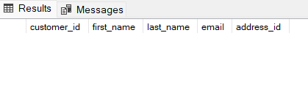
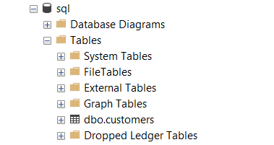
Output-

View : A view in SQL is a virtual table based on the result set of an SQL statement. It allows you to create reusable queries and simplify complex SQL operations.

Lets create a view :
Syntax –
CREATE VIEW view_name AS
SELECT column1, column2, ...
FROM table_name
WHERE condition;

Example – Now create a view named ‘customer_view’
Syntax –
CREATE VIEW customer_view AS
SELECT customer_id, first_name, last_name, email, address_id
FROM customers;


Output-

Command-2 :

ALTER :
This command is used to add, delete or change columns in the existing table. The user needs to know the existing table name and can do add, delete or modify tasks easily.

Syntax –
Syntax to add a column to an existing table.
ALTER TABLE table_name
ADD column_name datatype;

Example- In our customers table, add a new column countries.
Syntax –

ALTER TABLE customers
ADD COLUMN countries VARCHAR(50);

CONSTRAINTS : Constraints are the rules that we can apply on the type of data in a table. That is, we can specify the limit on the type of data that can be stored in a particular column in a table using constraints.

The available constraints in SQL are:

- NOT NULL: This constraint tells that we cannot store a null value in a column. That is, if a column is specified as NOT NULL then we will not be able to store null in this particular column any more.

- UNIQUE: This constraint when specified with a column, tells that all the values in the column must be unique. That is, the values in any row of a column must not be repeated.

- PRIMARY KEY: A primary key is a field which can uniquely identify each row in a table. And this constraint is used to specify a field in a table as primary key.

- FOREIGN KEY: A Foreign key is a field which can uniquely identify each row in a another table. And this constraint is used to specify a field as Foreign key.

- CHECK: This constraint helps to validate the values of a column to meet a particular condition. That is, it helps to ensure that the value stored in a column meets a specific condition.

- DEFAULT: This constraint specifies a default value for the column when no value is specified by the user.

Let us see each of the constraint in detail.

1.NOT NULL-
If we specify a field in a table to be NOT NULL. Then the field will never accept null value. That is, you will be not allowed to insert a new row in the table without specifying any value to this field.

For example, the below query creates a table customers with the fields customer_id and email as NOT NULL. That is, we are bound to specify values for these two fields every time we wish to insert a new row.
Syntax-
CREATE TABLE customers
(
customer_id NOT NULL
first_name VARCHAR(50),
last_name VARCHAR(50),
email NOT NULL
);

2. UNIQUE -
This constraint helps to uniquely identify each row in the table. i.e. for a particular column, all the rows should have unique values. We can have more than one UNIQUE columns in a table.

For example, the below query creates a table customers where the field customer_id is specified as UNIQUE. i.e, no two customers can have the same customer_id.
Syntax-
CREATE TABLE customers
(
customer_id INT NOT NULL UNIQUE
first_name VARCHAR(50),
last_name VARCHAR(50),
email NOT NULL
);

3. PRIMARY KEY -
Primary Key is a field which uniquely identifies each row in the table. If a field in a table as primary key, then the field will not be able to contain NULL values as well as all the rows should have unique values for this field. So, in other words we can say that this is combination of NOT NULL and UNIQUE constraints.
A table can have only one field as primary key.

For example , below query will create a table named customers and specifies the field customer_id as primary key.
Syntax-
CREATE TABLE customers
(
customer_id INT NOT NULL,
first_name VARCHAR(50),
last_name VARCHAR(50),
email VARCHAR(255) NOT NULL,
PRIMARY KEY (customer_id)
);

3. FOREIGN KEY -
Foreign Key is a field in a table which uniquely identifies each row of a another table. That is, this field points to primary key of another table. This usually creates a kind of link between the tables.

Consider the two tables as shown below:

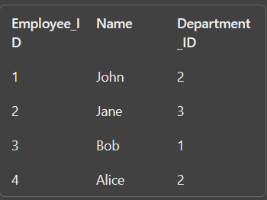
1) Employees table:

2) Departments table :
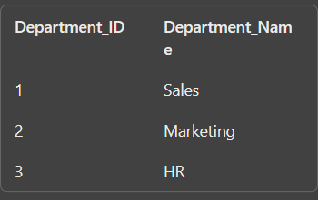

As we can see clearly that the field ‘Deparment_ID’ in Employees table is the primary key in Departments table, i.e. it uniquely identifies each row in the Departments table. Therefore, it is a Foreign Key in Employees table.

Syntax-

4) CHECK -
Using the CHECK constraint we can specify a condition for a field, which should be satisfied at the time of entering values for this field.

For example : below query creates a condition on email filed that is, the user will not be allowed to enter any mail address that does not contain string '%@mailid.com' at end.

Syntax-
CREATE TABLE customers
(
customer_id INT PRIMARY KEY,
first_name VARCHAR(50),
last_name VARCHAR(50),
email VARCHAR(100) CHECK (email LIKE '%@mailid.com'),
address_id INT
);

4) DEFAULT -
This constraint is used to provide a default value for the fields. That is, if at the time of entering new records in the table if the user does not specify any value for these fields then the default value will be assigned to them.
For example, the below query will create a table named customers and specify the default value for the field address_id as 1.

REMOVE – Now lets see how to remove column and constraint from a table.
CREATE TABLE customers
(
customer_id INT PRIMARY KEY,
first_name VARCHAR(50),
last_name VARCHAR(50),
email VARCHAR(100),
address_id INT DEFAULT 1
);

To remove a column and its associated constraint from a table in SQL, use the ALTER TABLE statement with the DROP COLUMN and DROP CONSTRAINT clauses.

Syntax to remove column:

Example: Now remove countries column from our customer table.
ALTER TABLE customers
DROP COLUMN countries;
ALTER TABLE table_name
DROP COLUMN column_name;

Syntax to remove constraint :
ALTER TABLE table_name
DROP CONSTRAINT constraint_name;

Example: Now remove ‘check_email’ constraint from our customer table.
ALTER TABLE customers
DROP CONSTRAINT check_email;

MODIFY- Modify generally refers to altering the structure or content of a database.
Lets see how can we modify Datatype and its Length with examples.

We modify the datatype of a column in a table using the ALTER TABLE statement with the MODIFY COLUMN clause.

Syntax:

Example: Now modify ‘first_name’ column datatype from our customer table.

We can also modify the length of a column's datatype using the ALTER TABLE statement with the MODIFY COLUMN clause.

Syntax:

Example: Now modify ‘first_name’ column datatype length from 50 to 100 in our customer table.

DROP- Drop statement is used to remove an existing database, column, table, view, or other database object.
Here is a example to drop a table

Syntax-

Example: Now drop our customers table.

DROP TABLE customers;

DROP TABLE table_name;
ALTER TABLE table_name
ALTER COLUMN first_name NVARCHAR(100);
ALTER TABLE table_name
MODIFY COLUMN column_name new_datatype;
ALTER TABLE table_name
ALTER COLUMN first_name NVARCHAR(50);

ALTER TABLE table_name
MODIFY COLUMN column_name new_datatype;
Now lets see how can we drop a Database.

Syntax-
DROP DATABASE database_name;

Example: Now drop sql database.
DROP DATABASE sql;

TRUNCATE - The TRUNCATE statement is used to remove all the rows from a table, while keeping the table structure .

Syntax-
TRUNCATE TABLE table_name;

Example- Now truncate customers table.
TRUNCATE TABLE customers;

This will delete all the rows from the ‘customers’ table, but the table structure, indexes, and constraints will remain intact.

Now here is the difference between DROP and TRUNCATE

